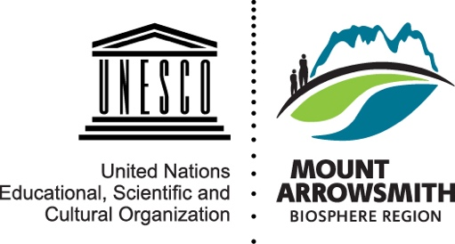
ROUNDTABLE COMMUNITY APPOINTMENTS
Two Positions: February 2023 - 2024
Application Form

APPLICATION for Consideration by MABR Staff and Roundtable Representatives for Appointments to the Mount Arrowsmith Biosphere Region (MABR) Roundtable.

Name:

Civic Address: |  |  | Municipality/Area:
Mailing Address (if different than above):

Postal Code: | Email:
Home Phone: |  | Work Phone:

Please attach additional pages if required to complete the following sections:

1. History of community involvement (100 words max):

2. History of professional involvement/experience (100 words max):

MABR.CA MABR Roundtable | Community Appointment | Application

3. Please list and describe your current community involvement and affiliations (100 words max):

4. What skills, experiences, or perspectives can you contribute to the MABR Roundtable? (250 words max)

I, _ ___________________________________, hereby signify that I am willing to accept a Community Appointment to the MABR Roundtable.

______________________________________ ____________________________
Candidate’s Signature Date

The purpose of this application form is to assist the MABR in selecting candidates for available positions. A candidate must sign this form to signify that they would be willing to accept the appointment. Completed applications and accompanying documents are confidential for use by MABR staff and current Roundtable representatives only.

Please submit application to:
Mount Arrowsmith Biosphere Region (c/o Graham Sakaki, Interim MABR Coordinator)
Vancouver Island University
900 Fifth Street
Nanaimo BC, V9R 5S5
Building 305 Room 442
Email: Graham.Sakaki@viu.ca | T: 250-753-3245 x 2687

References

Name | Phone | Email
1.
2.
3.

